**COIT13230(HT2, 2021)**

**Application Development Project**

Shahiduddin Tonmoy

Tsz Kit Choi

Contents

Project Introduction 4

Project Summary 4

Problem faced by client 4

Project Objectives 4

Constraints 5

Scopes and activities 5

Stakeholders Management 5

Project prerequisite 6

Project Schedule 7

Functional requirements 9

Function 1: Register 9

Function 2: Login 9

Function 3: Logout 9

Function 4: View the current page status 10

Function 5: View the details of a media 10

Function 6: Delete a media 10

Function 7: Change a media content 10

Function 8: Add a media content 11

Function 9: Import media in batches 11

Function 10: Export selected media content 11

Function 11: manages the database 11

Function 12: Manage user information 11

Function 13: Grant permission to a user 12

User stories 12

Risk Management 15

Risk estimation on the project 15

Risk occurrence probability judgment criteria 15

Risk Management Responsibility Allocation 16

Risk management measures 16

Risk analysis table 17

Profitability Analysis 18

Project Budget management 18

Monitoring and reporting 19

Quality Management 21

Overview 21

Quality Component metric 21

Quality Assurance Plan 26

Website Diagram 28

Software Architecture 29

Database Design 30

Behavior Modelling 30

Website Prototype 32

Homepage 32

Admin Login 33

Admin Dashboard 33

Event page 34

Jockey 35

Settings 36

Reference 41

**Link to Code Repository**

Github: <https://github.com/Shahiduddin/Keppel-FM>

# Project Introduction

## Project Summary

The client requirement is for a more mobile friendly and self-managing website for Keppel FM. The project has been implemented in a way where the admins can login and make changes to the website as they see fit. The website is designed using Laravel to make it more interactive and relevant.

## Problem faced by client

The clients have 2 main concerns regarding the website. They are:

• The client needs the website to be more user friendly.

• The website needs to have a simple approach to it so that the staff can manage it with little training.

## Project Objectives

The objectives of the project are listed below:

• The website needs to be more attractive and easier on the eyes so that the staff can navigate through them properly.

• The project will include many high standard and quality improvements to the website.

• The website will make sure to get rid of any redundant data.

• The website needs to be more user friendly.

• The staff needs to be able to make use of the website with little training.

• The navigation for the website needs to be more convenient.

## Constraints

The contains of the project is listed below:

• The resources and time management needs to be well managed.

• The accessibility and clarity of the website needs to be pleasant.

• The biggest constraints lie in the creativity and imagination aspect of the design as taste varies amount different people.

## Scopes and activities

**Scopes:**

• Changes in design layout, images and function.

• Adding activities to basic contents such as update, delete etc.

• Adding functionality to different detailed aspects of the website.

• Using different layout according to the requirements.

• Adding different aspects of social media for user content.

• Make the website more responsive.

**Activities:**

• Formatting and adding new content to the website.

• Adding functions that have not been included before.

• Designing the pages.

• Adding new layouts.

• Adding pages to the website.

## Stakeholders Management

Client: Keppel Fm

Project Owner: Central Queensland University

Project members and activities

Project Manager: Tsz Kit Choi

Business Analyst: Tsz Kit Choi, Shahiduddin Tonmoy

User interface design: Tsz Kit Choi, Shahiduddin Tonmoy

Software Development: Tsz Kit Choi, Shahiduddin Tonmoy

Software tester: Tsz Kit Choi, Shahiduddin Tonmoy

Project evaluator: Jamie Shield & Zakiullah Khan

## Project prerequisite

**Hardware Requirements**

The hardware requirements for the project are given below:

• PC/Laptop with 2GH processor

• Minimum of 2GB RAM

• Hard Disk memory 100 Gb

• Internet access

**Software Requirements**

The software requirements for the project are given below:

• Web browser such as Google Chrome, Internet Explorer etc.

• MYSQL database design

• Adobe photoshop

• Sublime or NetBeans or Dreamweaver for coding purposes

• Microsoft project: for Gant Chart

• UML: Draw UML diagram

• Virtual box: for project test deployment

**Hardware requirements for the Clients**

For the initial deployment of the project the clients would need to fulfill the following requirements:

• PC/Laptop with 2GH processor

• Minimum of 2GB RAM

• Hard Disk memory 100 Gb

• Internet access

**Software Requirements for the client:**

• Web browser such as Google Chrome, Internet Explorer etc.

# Project Schedule

Below is the Gantt Chart for overall project.

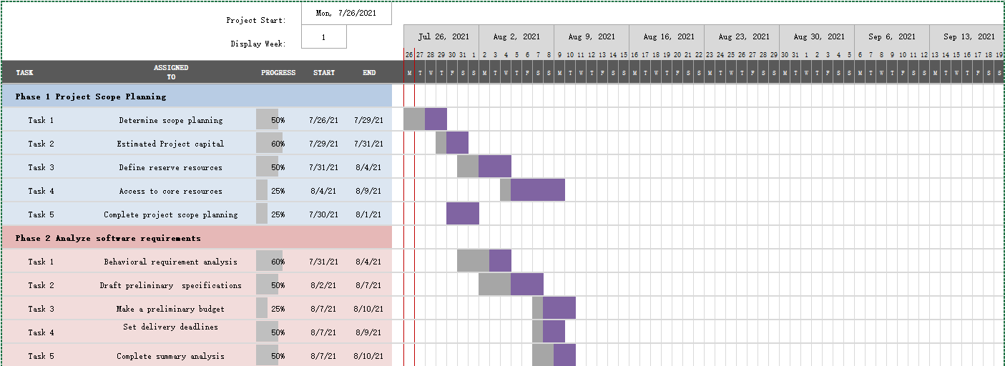 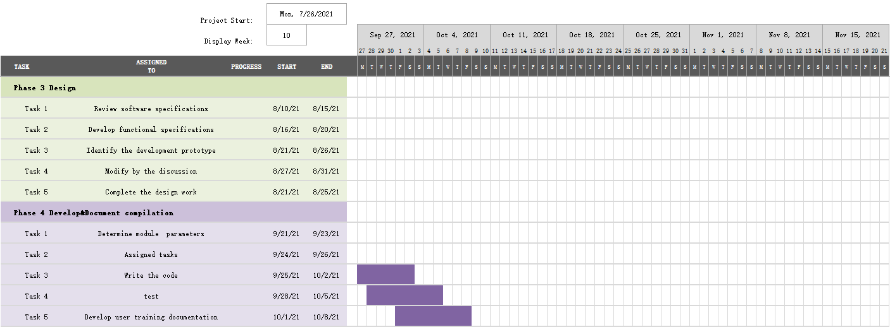

Figure 1：Gantt chart

**Agile product backlog**

|  |  |  |  |
| --- | --- | --- | --- |
| Kepper FM Project | | | |
| ID | Story | Estimation | Priority |
| 1 | As a maintenance I want to Handle staff needs | 4 | 8 |
| 2 | As a maintenance I want real-time monitoring | 4 | 7 |
| 3 | As a maintenance I want to deal with the  demand for single | 3 | 6 |
| 4 | As a maintenance I want intelligent diagnosis | 3 | 3 |
| 5 | As a maintenance I want to store data of  which system generated | 4 | 4 |
| 6 | As a staff I want to register | 2 | 1 |
| 7 | As a staff I want to login | 2 | 2 |
| 8 | As a staff I want to use demand for single | 5 | 5 |
| 9 | As a staff I want to use office automation | 5 | 9 |
| 10 | As a staff I'd like to release streaming media release | 6 | 10 |
| total |  | 38 |  |

Table 1：Agile product backlog

**Burn down chart**

Figure 2：Burn down chart

The figure shows the burndown progress of 10 weeks, where the blue represents the actual progress curve, and the orange represents the progress curve under the condition of constant productivity of members. As can be seen from the figure, the curve changed sharply in week 2 and week 9, indicating that our project needs to be adjusted according to the actual situation.

**Agile release plan**

|  |  |  |  |  |  |
| --- | --- | --- | --- | --- | --- |
| **Week 5** | **week6** | **week 7** | **week8** | **week 9** | **week 10** |
| Release planning | | |  |  |  |
|  |  |  | Load data to coud |  |  |
|  | Prioritize functions |  |  |  |  |
| Define functionality |  |  |  |  |  |
| Create account | |  | Test the project | | |
|  |  |  | Check stuff demands |  |  |
| Coding |  |  | Maintain the website |  |  |
| Develop the website | | | |  | Plan high |
|  |  | safety monitoring |  |  |  |
|  | 1.0  Release |  | 2.0 Release |  | 3.0 Release |

Table 2：Agile release plan

The above table shows the release version of the project. From 1.0 to 2.0, and finally to 3.0, this is a very comprehensive approach. After the details of each small unit are determined, the work can be effectively carried out to ensure the release of the version on time..

# Functional requirements

## Function 1: Register

User Story: As a website visitor, I want to register for the site so that I can get a login account

Acceptance criteria:

1. Suppose I click register, I should see a prompt to complete the registration.

2. Suppose I'm on the sign-up page and the site accepts my input and displays it.

3. If I register successfully, I can see the login interface, enter the corresponding information and log in.

## Function 2: Login

User Story: As a website visitor, I want to log on to the site so I can get personalized service

Acceptance criteria:

1. Assume that the user has entered the correct login information on the login page and is allowed to use the personalization function.

2. Assume that the user is not allowed to use the personalization function after entering incorrect login information on the login page.

## Function 3: Logout

User story:as a logged in user, I want to log out of the site and revoke my logon status

Acceptance criteria:

1. Assume that the user clicks logout on the interface, and the login status of the user is revoked.

2. If the user does not perform any operation for more than 15 minutes, the user's login status is revoked.

## Function 4: View the current page status

User stories, as a website user, I want to see all the media information on the website so that I can have a broad understanding of the media content.

Acceptance criteria:

1. Assume that the user clicks to view media information on the interface, and the media information is displayed.

## Function 5: View the details of a media

User story: As a website user, I want to search for media information by name so that I can quickly find media content.

Acceptance criteria:

1. Assuming that the user is accurately entering media information, the website searches for the corresponding media information and displays it.

2. Assume that after the user enters some words of the media information, the website vaguely searches for the media information that contains the word in the name.

## Function 6: Delete a media

User story: as a website user, I would like to press Delete media information to facilitate the removal of unsatisfactory media content.

Acceptance criteria:

1. Assume that a user deletes a media item on all media information pages.

2. Assume that the user can delete the media after searching for the media.

## Function 7: Change a media content

User story: As a website user, I want to change a media information to make it easier to modify unsatisfactory media content.

Acceptance criteria:

1. Assume that a user clicks to modify a media item on a media information page.

2. Assume that the user can modify the media after searching for the media.

## Function 8: Add a media content

User story, as a website user, I want to press New Media info to add media content.

Acceptance criteria:

1. Assume that a user adds a media item on all media information pages.

## Function 9: Import media in batches

User Stories: As a website user, I want to bulk import media information to facilitate a large amount of new media content.

Acceptance criteria:

1. Assume that the user has selected batch import. On the page displayed, select a file to import.

2. Assume that users can import files in different formats when selecting the file page.

3. Assume that a file template is available for users to download during batch import.

## Function 10: Export selected media content

User Story: As a website user, I want to export media information so that it can be easily downloaded.

Acceptance criteria:

1. Assume that the user is exporting the corresponding media content.

2. Assume that you can export files in different file formats on the file export page.

## Function 11: manages the database

User Story: As an administrator, I want to manage the data sheet information to facilitate the maintenance of site content.

Acceptance criteria:

1. Assume that the administrator can operate the specified data table when managing data.

## Function 12: Manage user information

User Stories: As an administrator, I want to manage user information so that it is easy to maintain user data.

Acceptance criteria:

1. Assume that the administrator can add a specified user when adding user data.

2. Assume that when deleting user data, the administrator can delete the specified user, and the user no longer has the permission to use the website.

3. Assume that the administrator can modify the information of a specified user when modifying user data.

4. Assume that when the administrator searches for user data, the data can be displayed for the specified user.

5.Assume that the administrator succeeds in performing operations on user information in real time.

## Function 13: Grant permission to a user

User Stories: As an administrator, I want to give users permissions so that they can operate with limited permissions.

1. Assume that the administrator can assign permissions to a user when adding a user.

Acceptance criteria: Assume that the administrator succeeds in performing operations and users can perform operations on the content with their own rights.

# User stories

The above use case has a total of two actors involved in the system. The five roles are Kepper FM staff and GoDaddy maintenance staff.

Kepper FM staff: Managers who have accounts on the site. They have access to much of the system and can manage their own content.

GoDaddy Maintenance: Is a maintenance personnel who maintains the website and can handle information about the needs of Keeper FM employees with "request as maintenance personnel.

Figure 2 shows the maintenance functions required by maintenance personnel. Among them, there are mainly intelligent diagnosis, office automation management and processing staff needs. Figure 3 shows all the individual use cases that employees are involved in. In addition to registration and login, there is also the maintenance of streaming media resources. Figure 4 is the largest use case diagram, showing all of the interactions that employees and members have with maintainers.

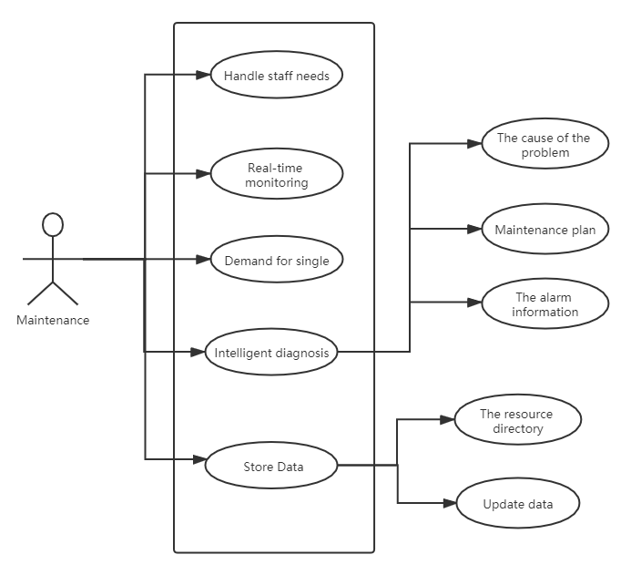

Figure 3 Maintenance user story

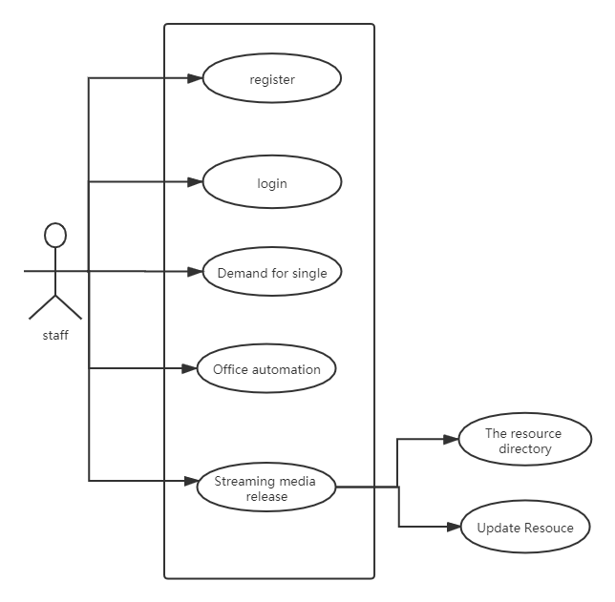

Figure 4 Staff user story

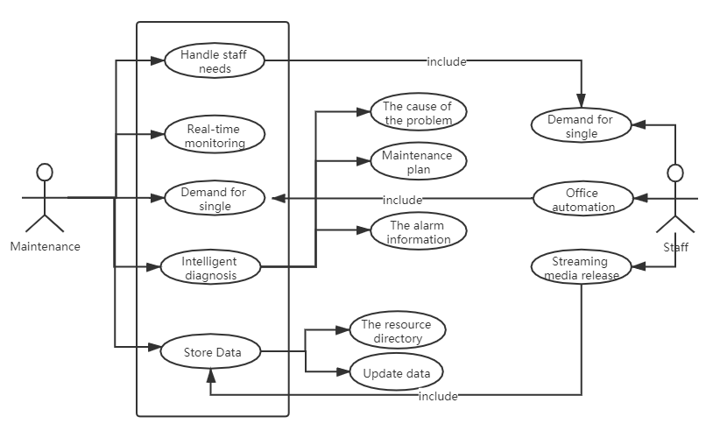

Figure 5 Overall User Story

# Risk Management

## Risk estimation on the project

|  |  |  |  |  |  |  |
| --- | --- | --- | --- | --- | --- | --- |
| no | **Risk  categories** | **Risk  description** | **Probability of  occurrence** | **Influence  degree** | **Risk level** | **Response plan** |
| 1 | Market risk | Small product  market | high | middle | middle | Develop products  of the same type |
| 2 | Increase in  competitors | middle | low | low | Communicate the advantages of  the project to the client |
|  |  |  |  |  |  |  |
| 1 | Technical risk | Technical  reserves | middle | middle | middle | Collaboration with research institutions |
|  |  |  |  |  |  |  |
| 1 | Financial risk | Costs are higher than expected | middle | low | low | Improve cost analysis |
| 2 | Critical equipment  missing | low | low | middle | Supplier  substitution |
|  |  |  |  |  | low |  |
| 1 | Management  risk | Project status is  unclear | low | low | low | Enhance communication management |

Table 3: Project risk level management

Identify potential hazards in the project, including inherent, potential or man-made hazards and events caused by equipment, operation, maintenance and other aspects. Based on the integrity of the system, the existing safety level of the system is comprehensively evaluated, and the corresponding safety suggestions and measures are put forward. The following are the criteria for judging the probability of risk occurrence:

## Risk occurrence probability judgment criteria

High risk: > 60% chance of risk occurring

Medium risk: 30%~ 60% chance of risk occurring

Low risk: <30% chance of risk occurring.

## Risk Management Responsibility Allocation

According to the risk checklist and the actual situation of the project, the project team identifies the risks in each stage of the project life cycle, analyzes and evaluates the probability and impact of the risks, ranks the risks according to their severity and probability, and works out the control measures to deal with the risks. Track the status of the identified risks and record the risk tracking. When risks occur, strict implementation of risk control measures to minimize the impact of risks.

|  |  |
| --- | --- |
| role | Duties and responsibilities |
| Project director | 1 Understand project risks and pay attention to the status of project risks |
| Ensure the resources required by the project team to implement risk control measures |
| The project manager | Identify risks at all stages of the project life cycle |
| Organize to analyze and evaluate the severity and possibility of project risks |
| Formulate and implement risk control measures |
| 4 Track risk status |
| Members of the project | Identify and feedback risks at all stages of the project life cycle |
| Execute risk control measures |
| Assist project manager to complete risk management |
| Project stakeholders | Identify and analyze risks at all stages of the project life cycle |
| 2. Monitor project risks |
| Implement risk control measures related to project stakeholders |
| SQA | Supervise and guide the project team to implement the risk management process |

Table 4: Risk Management Responsibility Allocation

## Risk management measures

(1) The causes of risks should be controlled before the project starts, and every means should be taken to mitigate the impact of risks after the project starts. (2) Understand the reasons leading to the change of project developers, control the above reasons during the project development, and minimize the flow of staff.

(3) Appropriate measures shall be taken in terms of working methods and techniques to prevent loss of work caused by personnel movement.

(4) The project development information shall be released and exchanged in time during the development process.

(5) Establish organizational structure, determine document standards, and generate documents in time.

(6) Review the work collectively so that most people can understand the details of the work and keep up with the progress of the work.

(7) Reserve personnel for key technologies.

## Risk analysis table

|  |  |  |  |  |  |  |
| --- | --- | --- | --- | --- | --- | --- |
| Sort | The input | Risk events | Possibility | Impact | Risk | Measures taken |
| 1 | The customer | Customer demand is not clear, increasing demand, resulting in demand spread | 70% | 50% | 35% | Ask the professional demand analyst and the customer representative to  have a detailed conversation, learn more about the customer's idea, and think about the problem from the customer's point of view |
| 2 | The contract | The schedule is demanding and the contract amount and date are limited | 30% | 50% | 15% | Some internship students can do support work,  one to reduce costs, two to speed up the progress. |
| 3 | Historical Project Information | Developers don't pay attention to testing | 30% | 40% | 12% | It is mandatory that each piece of code be  retained as a test unit to be checked by SQA. |
| 4 | WBS | There is no proper test case for the open system standard for requirements | 20% | 80% | 16% | Find a professional testing company  to complete the testing work |
| 5 | Historical Project Information | The flow of developers | 15% | 60% | 9% | 1) Pay attention to the communication of the project team and keep abreast of the developments of the developers. 2) Control the documents in the project process; 3) demodulate personnel from other project teams;  4) recruit external personnel with such development experience |
| 6 | System design review | Not enough time for product testing | 50% | 50% | 25% | 1)Work overtime. 2) Modify the plan to eliminate some tasks.  3) Discuss with the client to extend some time |
| 7 | Requirements and Plans | The adoption of new technology may lead to delays in progress | 50% | 30% | 15% | 1) train the developers;  2) find experts to guide them;  3) take the approach of learning while developing, requiring them to master the technology within the specified time |

Table 5: Risk analysis table

# Profitability Analysis

The phases of a complete project development include: planning and use-case specification, project structure and risk assessment, business function specification, code implementation, testing, operations manual, and so on. A project requires a large amount of financial resources and manpower. If there is no good risk planning, it will have a great impact on the future progress.

Here's what you learned from the project:

1.Good documentation: This is an important part of the development process, and the lack of documentation can be extremely troublesome for future errors, upgrades, and module reuse. This can result in significant code changes.

2.Code writing habits: helps with code migration and error correction, and also helps with collaboration among technicians.

3.Understanding requirements: Truly understanding the role of another module makes the project more secure and stable.

4. enhance competitiveness.

5.A mobile friendly website will be provided.

Following are the advantages that we received after this project:

1. Learn professional knowledge, enrich ourselves. Know what I need to know about my career.

2. Understand social reality, including interpersonal communication, communication style and related etiquette.

3. Learn teamwork, be good at using the wisdom of others, patiently listen to ea ch member's opinion.

4. Master the way to deal with things, improve their mind and the ability to face the problem

5. The first time to contact customer needs, from the customer's point of view to think about the problem, design a more reasonable software structure.

# Project Budget management

Software projects face a dilemma of goals versus schedule and cost. The first step in software estimation is to determine whether project goals are realistic enough to achieve them in a manageable manner. Estimates don't have to be accurate, they have to be useful. Here is the table for budget management:



Table 6: Risk Plan of current project

Software projects can be affected by budgets, and the lack of a budget can lead to high costs. The table above shows the number of hours each person worked and the corresponding cost, which comes to $75,000.

# Monitoring and reporting

(1) Weekly status reports

|  |  |  |  |
| --- | --- | --- | --- |
| Project name： Kepper FM Project | | | |
| Record no | Weekly status reports _001 | Task stage | Startup phase |
| head | Tsz Kit Choi | writers | Tsz Kit Choi |
| Project schedule | | | |
| |  |  |  |  |  |  | | --- | --- | --- | --- | --- | --- | | **Task name** | **Scheduled completion time** | **Whether delay** | **current progress** | **Those responsible** | **note** | | Scope planning | 2021.7.29 | no | 50% | Tsz Kit Choi |  | | Assess feasibility | 2021.7.29 | no | 50% | Tsz Kit Choi |  | | | | |
| Kepper FM Project of this week's progress: | | | |
| Make a plan to ensure quality and arrange the details of team work .  Conduct in-depth research on the application scenarios proposed by the builder | | | |
| problems and risks now | | | |
| Project progress is slow | | | |
| Customer needs to cooperate with matters | | | |
| Specific requirements need to be put forward | | | |
| Priorities for next week | | | |
| 1. Identify customer needs 2. Assign people as soon as possible 3. Speed up project schedule | | | |

Table 7: Weekly status report

(2) Project Team status meeting

|  |  |  |  |  |
| --- | --- | --- | --- | --- |
| **no.** | **Problem description** | **Deadline** | **status** | **Resolution of the situation** |
| 1 | Identify appropriate personnel | 2021/7/26 | completed |  |
| 2 | Sort out the corresponding needs for selection | 2021/7/26 | processing |  |
| 3 | Establish analytical application model | 2021/7/31 | processing |  |
| 4 | Conduct in-depth research on application scenarios proposed by customers | 2021/7/31 | processing |  |
| 5 | Develop project schedule | 2021/7/31 | processing | Submit preliminary project inversion schedule |
| 6 | Submit the list of relevant personnel | 2021/7/31 | processing | Submit a preliminary list of personnel |
| 7 | Table the associated data according to the requirements of the application scenario | 2021/7/31 | processing |  |
| 8 | Contact Kepper FM to participate in program development | 2021/7/31 | processing |  |

Table 8: Project Team status meeting

(3) Project Owner status meeting:

|  |  |  |  |
| --- | --- | --- | --- |
| The theme | Kepper FM | | |
| Record number | Project Owner status meeting_001 | | |
| Date | 2021-07-24 | Address | The classroom |
| The host | Kepper FM head | The recorder | Tsz Kit Choi |
| attendees | The customer：Kepper FM stuff  Unit construction：Project team member | | |
| The main purpose of this meeting is to report and discuss the current problems and progress of the project.  Meeting content and decision：  **A.Content of contractor's report**：  1.According to the revised plan plan requested by the team meeting, the plan work arrangement plan was deeply optimized.  2. Adjust personnel and optimize personnel structure.  **B.The client summarizes the contents and requirements for the next phase of work：**  1.Demonstrate and screen the landscape schemes required for the construction of the platform, and submit the mature schemes that meet the construction requirements and expectations of the project to the customer for discussion, selection and confirmation.  2.The client contractor determines the detailed list of on-site personnel and proceeds with the project. | | | |

Table 9: Project Owner status meeting

# Quality Management

## Overview

Software quality can be considered from the following six aspects:

1.How many features of the software plan have been completed? (Product completion)

2.Are the finished features working well? (Is there anything wrong with the product?)

3.How is the work done? (Parts of the test that are not completed may be at risk)

4.What is the quality of our r&d process? (Process quality is also quality, in fact we believe that product quality is rooted in process quality rather than testing)

5.Is there any deviation in our product development plan? (If the plan deviates, attention should be paid and measures should be taken)

6.What are the trends in product quality? (Product quality trend analysis can help predict the next direction of the project and prevent problems)

## Quality Component metric

|  |  |  |  |
| --- | --- | --- | --- |
| Measurement module | Metrics | Statistical methods | Measurement description |
| Product completion | 1. Demand pass rate | Approved requirements/planned requirements | Reflect the degree of completion of requirements |
| 2. Function point pass rate | Function point passed/function point tested | Reflect the degree of completion of requirements |
| 3. Risk aversion | Risks have been avoided/estimated | Product response to known risks |
| Quality of the product | 4. Test pass rate | Number of tests executed/planned | Measuring product quality |
| 5. Defect density | Total defects/thousand lines of code | Can be converted to: total number of defects/corresponding modules |
| 6. Distribution of defect severity levels | Number of defects corresponding to severity level/total number of defects | A two-dimensional distribution of quantity and severity |
| 7. Defect type distribution | Number of defects of corresponding type/total number of defects | The quality of software is measured by the proportion of  distribution of corresponding defect types |
| 8. Distribution of defective modules | Number of defects/total number of defects in the corresponding module | The quality of the whole software module is measured by  the distribution proportion of corresponding defect modules |
| 9. Defect repair rate | Fixed defects/total defects | Percentage of defects that have been fixed |
| Test completion | 10. Use case coverage | Number of designed use cases/planned design use cases | Used to monitor the progress of test designs |
| 11. Test execution rate | Number of tests executed/Number of tests scheduled to execute | Tests have been executed, for test progress tracking |
| 12. Test pass rate | Number of tests passed/number of tests scheduled to execute | Test pass ratio |
| Quality measurement | 13. Defect life cycle | Total duration of defects/defects | Measure the ability of the r&d team to fix defects |
| 14. Test case hit ratio | Number of defects/use cases | Measure the effectiveness of your test design |
| 15. Secondary failure rate | Number of defects reopened twice/total number of defects | Multiple remeetings of defects lead to a longer repair cycle |
| 16. Defect efficiency | Number of valid defects/total defects | Test how many defects submitted by the team are valid defects |
| 17. Defect detection rate | Number of defects found at a test level /(Total number of defects + number of new defects after delivery) | Measure the effectiveness of a test level |
| 18. Defect removal rate | Defects are familiar when the number of removed defects is settled/when the phase introduces defects | Count the number of defects in a given phase and the  proportion that were resolved in the current phase |
| 19. Test based on stability | Number of new or modified test cases caused by requirements change/total test cases | Reflect the stability and quality of the test basis and requirements documents |
| Planned deviation measure | 20. Workload deviation | (Actual workload - calculated workload)/ planned workload | Is there any unplanned work not included in the estimate |
| 21. Deviation in work schedule | We are over schedule | Statistical deviations in work schedule to reveal project time risks |
| 22. Proportion of budget usage | Test budget spent (people/days)/ total test budget planned | To test the budget |
| 23. Problem wait time | Specific problem waiting time | Help measure project bottlenecks |
| Product Quality Trend | 24. Defect arrival rate | Number of defects/time cycle | Reflect the trend of project products |
| 25. Defect convergence | Number of defects left/time cycle | Determine the quantity of follow-up product quality |
| 26. Defect introduction rate | Number of new defects/thousand lines of code added | Measure the impact of product increments and modifications on quality |

Table 10: Project Quality Management

1.1 Test completion: Combine test execution rate and pass rate for statistics

|  |  |  |  |  |  |  |  |  |
| --- | --- | --- | --- | --- | --- | --- | --- | --- |
| Completion of function points | | Completion rate of  function points | Test pass  function points | Complete the number of  functions under test | Test to fail | Test block | Incomplete function points | Number of function points |
| 1 | Module A | 58% | 45% | 97 | 27 | 8 | 81 | 213 |
| 2 | Module B | 64% | 53% | 180 | 36 | 19 | 102 | 337 |
| 3 | Module C | 72% | 50% | 108 | 21 | 11 | 38 | 178 |
|  | **Total** | **65%** | **49%** | **385** | **84** | **38** | **221** | **728** |

Table 11: Test Completion

Figure 6: Test Pass rate

1.2 Product completion: The pass rate of function points is used as statistics

|  |  |  |  |  |  |  |
| --- | --- | --- | --- | --- | --- | --- |
| Completion of function points | | Completion rate of  function points | Test pass  function points | Complete the number of  functions under test | Incomplete function points | Number of function points |
| 1 | Module A | 56% | 40 | 44 | 28 | 72 |
| 2 | Module B | 61% | 62 | 75 | 26 | 101 |
| 3 | Module C | 73% | 41 | 56 | 0 | 56 |
|  | **Total** | **63%** | 143 | **175** | **54** | **229** |

Table 12: Product Completion

Figure 7: Test Pass rate

1.3 Product quality: defect density statistics

|  |  |  |  |  |
| --- | --- | --- | --- | --- |
| Defect density statistics | | Defect density | The total number of defect | Number of function points |
| 1 | Module A | 27.78% | 20 | 72 |
| 2 | Module B | 28.71% | 29 | 101 |
| 3 | Module C | 26.79% | 15 | 56 |
| 4 | **Total** | 27.95% | 64 | 229 |

Table 13: Product quality

1.4 Quality of r&d process: statistical defect life cycle

|  |  |  |  |  |  |
| --- | --- | --- | --- | --- | --- |
| Defect life cycle(h) | | Mean life cycle | Longest life cycle | Shortest life cycle | The total number of defect |
| 1 | Module A | 48.38 | 168 | 1 | 20 |
| 2 | Module B | 33.84 | 96 | 1 | 29 |
| 3 | Module C | 25.68 | 115 | 1 | 15 |
| 4 | **Total** | 35.97 | 126 | 1 | 64 |

Table 14: Quality Process

1.5 Deviation degree of plan: focus on statistics of progress deviation

|  |  |  |  |  |  |  |  |
| --- | --- | --- | --- | --- | --- | --- | --- |
| Scheduled start time | | Scheduled completion time | Completed time | The number of plan | Actual completion time | Planned workload (person/day) | Deviation (day) |
| 1 | Task A | 2021/7/26 | 2021/8/1 | 2 | 2021/8/1 | 12 | 0 |
| 2 | Task B | 2021/8/3 | 2021/8/17 | 1 | 2021/8/17 | 14 | 0 |
| 3 | Task C | 2021/8/18 | 2021/8/23 | 2 | 2021/8/26 | 10 | 3 |
| 4 | **Total** |  | 126 | 2 |  | 36 | 3 |

Table 15: Deviation degree of plan

1.6 Quality trend: Make statistics based on defect arrival rate and residual rate

|  |  |  |  |  |  |
| --- | --- | --- | --- | --- | --- |
| Defect convergence | | first week | second week | third week | fourth week |
| 1 | Defect arrival rate | 3 | 18 | 31 | 12 |
| 2 | Defect retention rate | 33 | 21 | 30 | 19 |

Table 16: Quality trned

Figure 8: Defect convergence

## Quality Assurance Plan

Roles for Responsibilities

|  |  |  |
| --- | --- | --- |
| Name | Role | Responsibility |
| [Tonmoy, Shahiduddin](https://aims.cqu.edu.au/student/students/detail/12063359) | Duty | Quality duty |
| [Tonmoy, Shahiduddin](https://aims.cqu.edu.au/student/students/detail/12063359) | Project Head | Quality Mentoring, coaching and testing |
| Tsz Kit Choi | Software Developer and Tester | Quality for development and testing |
| Tsz Kit Choi | Document writer | Quality edit |

Table 17: Quality assurance plan

Quality Metrics

|  |  |  |  |
| --- | --- | --- | --- |
| Metric | Standard | Method | Quality Criteria |
| Cyclomatic Complexity | The site should be  The website needs to be simple to operate. | Audit | Based on the rationality of mathematical model design, it is necessary to analyze the time and space complexity of an algorithm to determine the feasibility of the algorithm. |
| Portability | Websites can be reused | Audit | Software can be compatible to a platform and can be reused. |
| Maintainability | Websites can be easily maintained | Audit | Refers to the ability of a software product to be modified. Modifications include modifications, optimizations, and descriptions of functional specification changes. |
| Functionality | Websites can clearly reflect the needs of users. | Test | The ability of software to meet users' explicit and implicit requirements under specified conditions. |
| Reliability | Websites can respond to questions. | Test | To reduce software defects or to avoid exposing internal design details. |
| Usability | The website is user-friendly. | Audit and test | The ability of a software product to be used, understood and learned under specified conditions. |
| Efficiency | The site has good performance. | Future feature adding and modifiy. | The ability of a software product to provide appropriate performance relative to the amount of all resources under specified conditions. |
| Security | System must be safe. | Test | Security requires consideration of user privacy, whether there are vulnerabilities, and whether the running process will blink. |
| User Interface | The website should  have consistent design. | Audit and test | Provide a set of standard interfaces for the basic data format and the corresponding business processes. |

Table 18: Quality Metrics

# Website Diagram

The diagram used by the website is the very popular MVC which is used for building complex web services. It is a very popular for used in most modern web applications. MCV stands for Model, View and Controller.

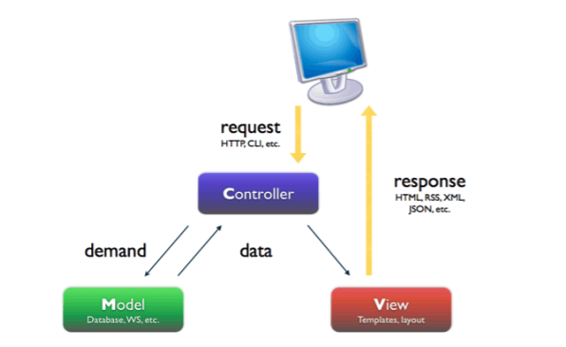

Figure 9: website diagram

Source: http://stackoverflow .com/questions/5966905/which-mvc-diagram-is-correct-web-app

From the diagram above we can see the 3 key aspects of the diagram

**Model**:

The model is the aspect of the system where all the related data tasks are managed. It stores data, as well as their corresponding logic. Data that is being transferred between Controller and associated business logic is represented by Model. It reduces the code that needs to be written by the developers. It is the main source of data for the whole website.

**View**:

The view is responsible for the graphical user interface All forms, buttons, graphics and HLML elements are present in the view section of the web application. View is created with data from the Model component. Model gives information to view, and view would present the output to users. This is what we can normally call the web design or template of the website.

**Controlle**r:

The controller is mainly responsible for event handing. It works as a middleman between View, Model, and the user. It manages the relationship between a view and a model and respond to the user requests accordingly.

In our application, it is the part that handles user interaction. Mouse or keyboard inputs from the user would be interpreted by the Controller. And the controller would inform view and model component to make changes.

The Controller would send commands to Model for state update. For example, in our website, change to a selected event. It would also send commands to associated view change what is presented to user. For example, user scroll down to the bottom of page.

# Software Architecture

Given below is the software architecture for Laravel.

Here we can see how the software model works with the user request:

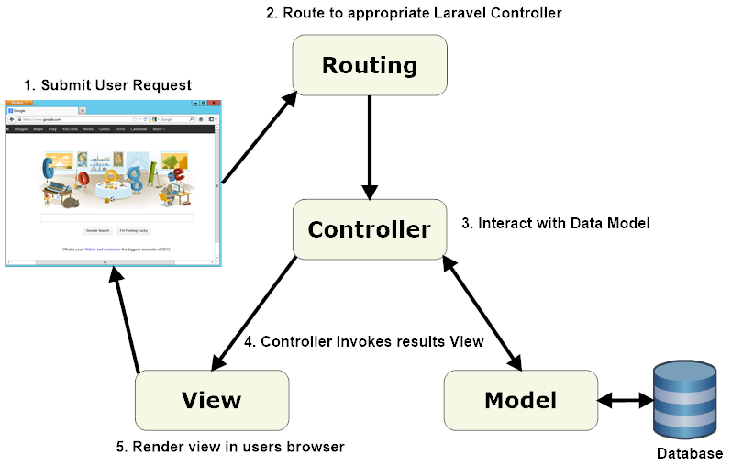

Figure 10 Software Architecture

**Source: http://www.cutehits.com/2017/06/general-architecture-of-laravel-based-application/**

# Database Design

Given below is the database design created for the website:  
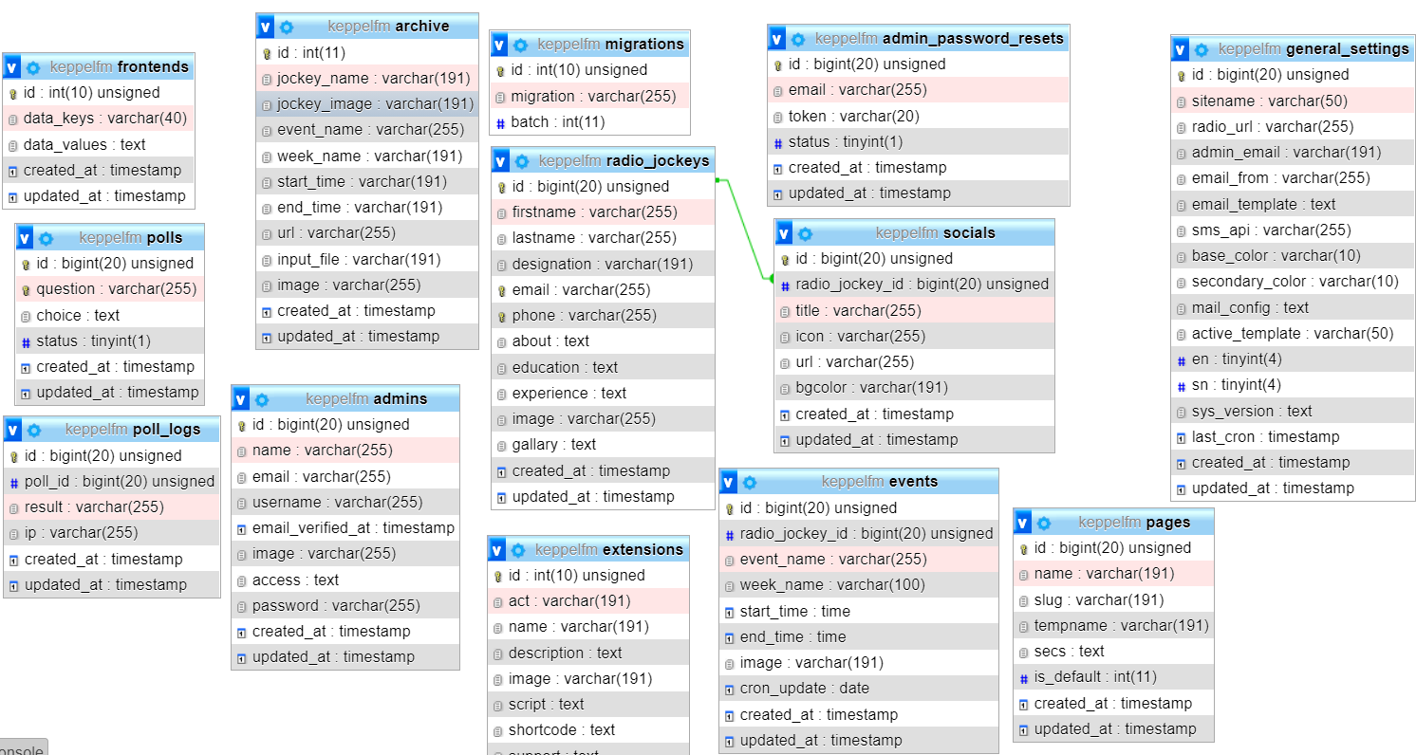

Figure 11 Database Design

Behavior Modelling

Behavior modelling shows the flow of each task the website will commit and show the workflow of the task at hand. Below is the different task the user will make:

**Behavior modelling for admins**:

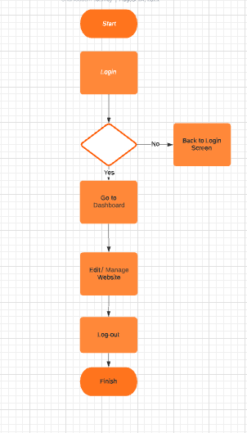

Figure 12 Behavior modelling for admins

**Behavior model for Visitors:**

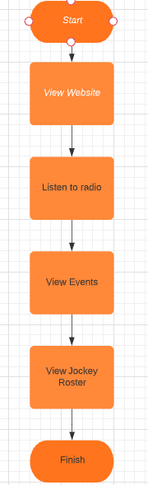

Figure 13: Behavior model for Visitors

Website Prototype:

Here we will showcase the initial stage of the website:

Homepage**:**



Figure 14: Home Page

Here we can see a dynamic icon for the Keppel FM and we used blade template to create the structure of the website. Initially there is function but further into the project, more functions will be added to increase the activities of the website.

Figure 15: Event Schedule

This page shows the past event by date.

Figure 16: Previous Event

This page is an additional design for the homepage. It allows user to view previous events, and RJ.

Admin Login**:**

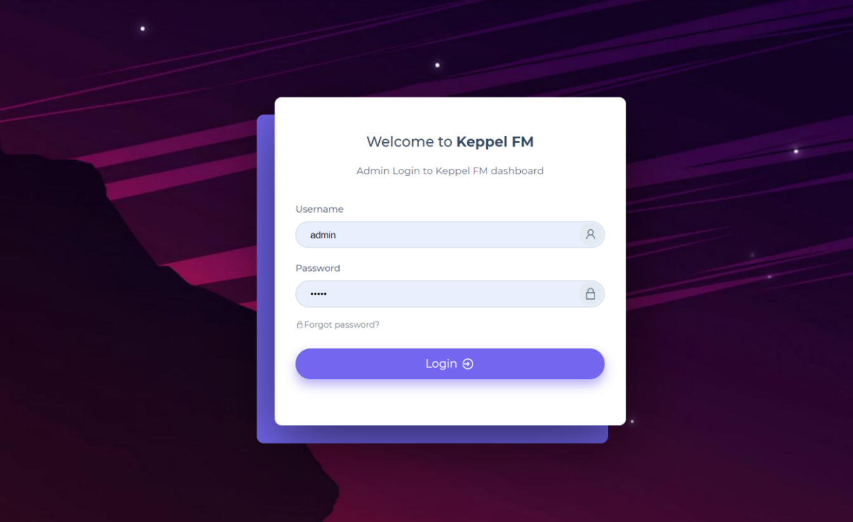Figure 17: Admin Login

From here the admins can log-in to the website by putting in their username and password.

Admin Dashboard**:**

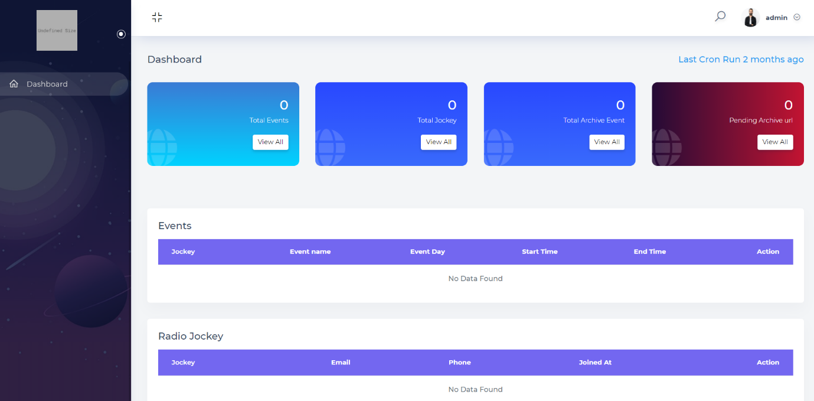

Figure 18 Admin Dashboard

Here the admins can view the event or the activities of the website and made changes to website like set even dates and Jokey lineup. They can also make changes to the visual appeals of the website to better suit their images.

## Event page

Figure 11 All archive Events

Figure 19 Calendar

## Jockey

Figure 20: All Jockeys

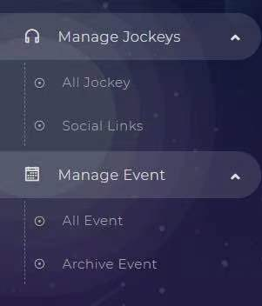

Figure 21: Manage Jockey

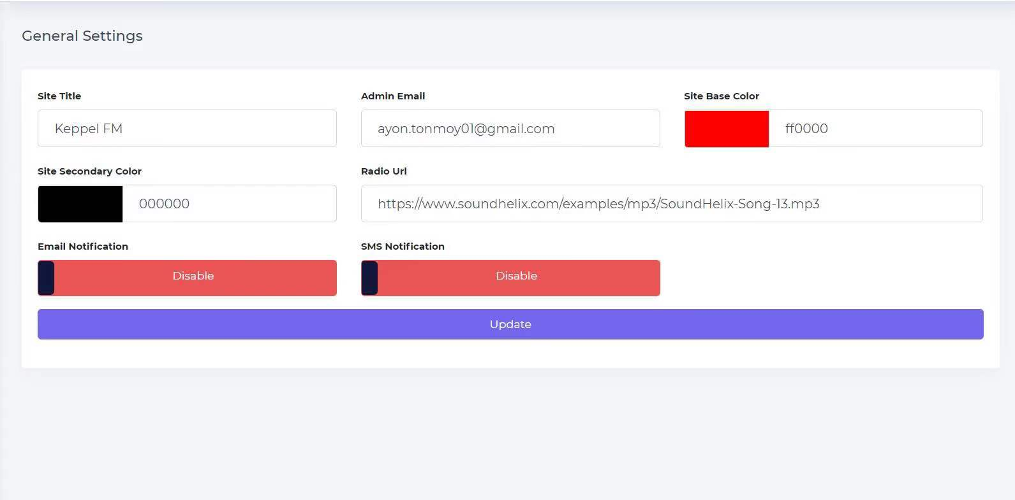

## Settings

Figure 22: General settings

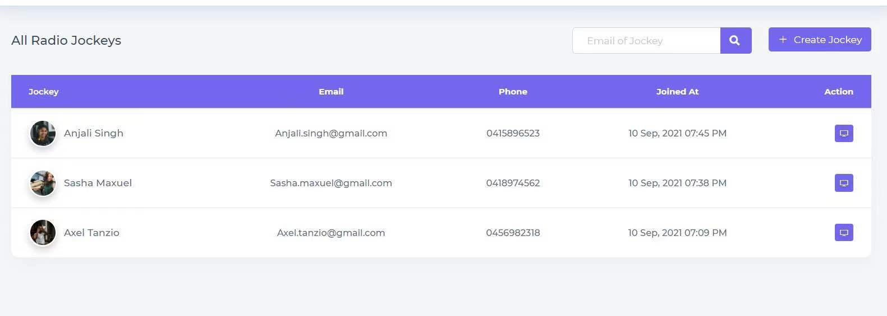

Figure 23: Jockeys

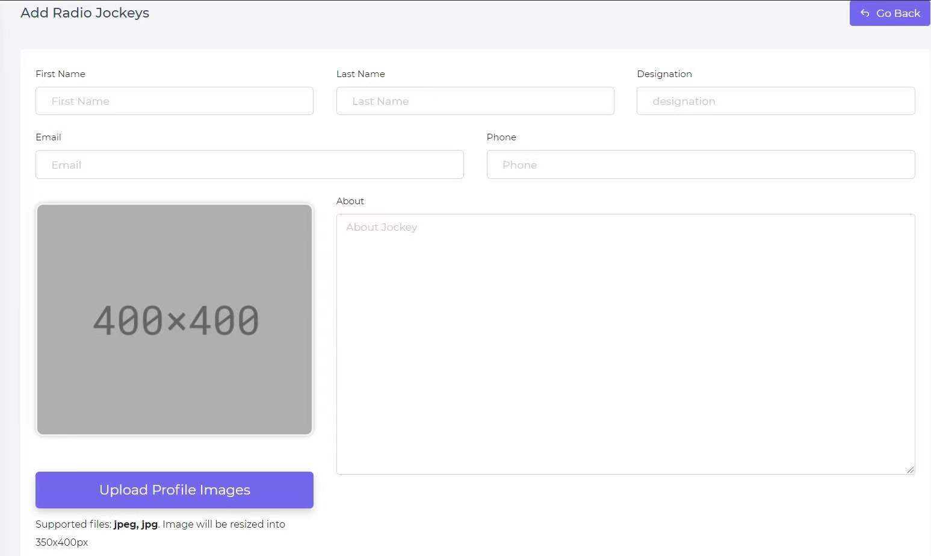

Figure 24: Add radio jockeys

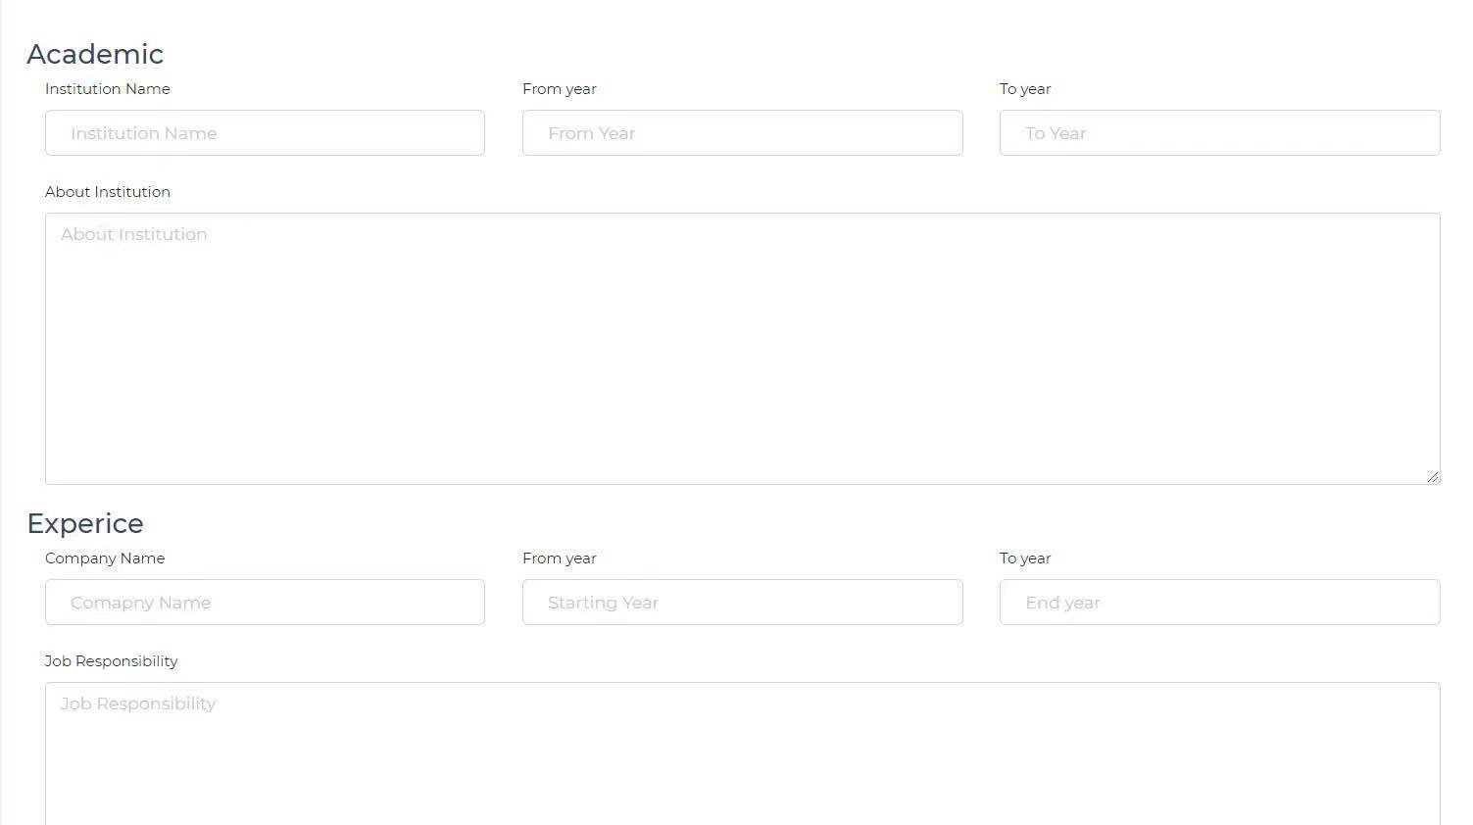

Figure 25: user background setting

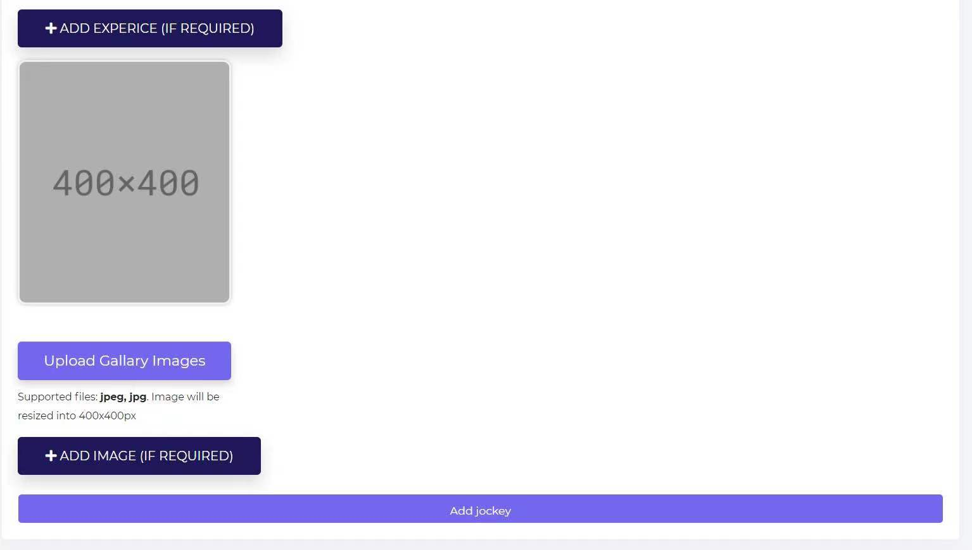

Figure 26: Add image

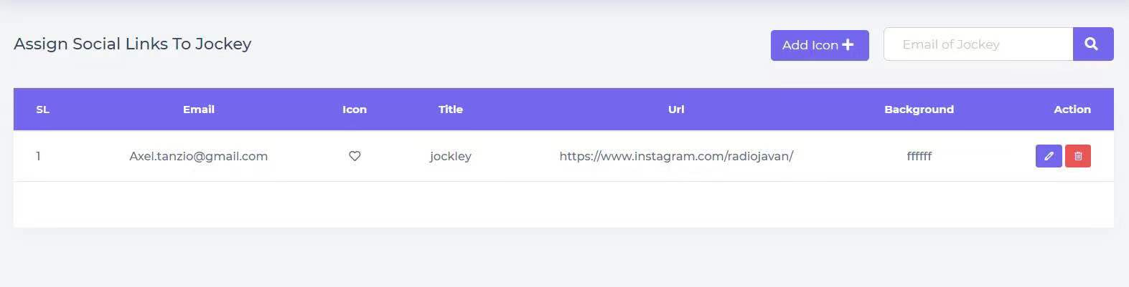

Figure 27: Assign social links

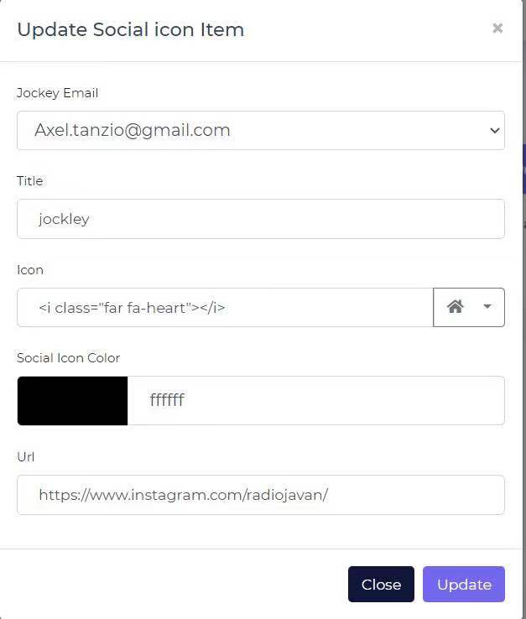

Figure 28 Social Profile Setting

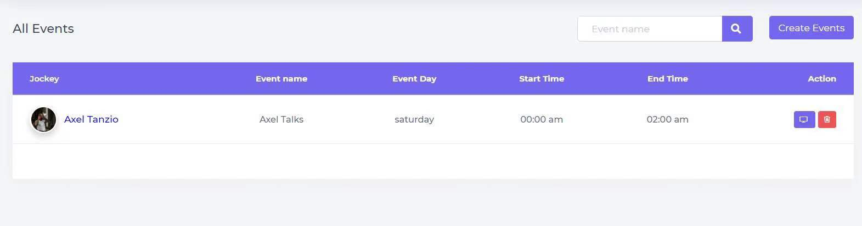

Figure 30 All events 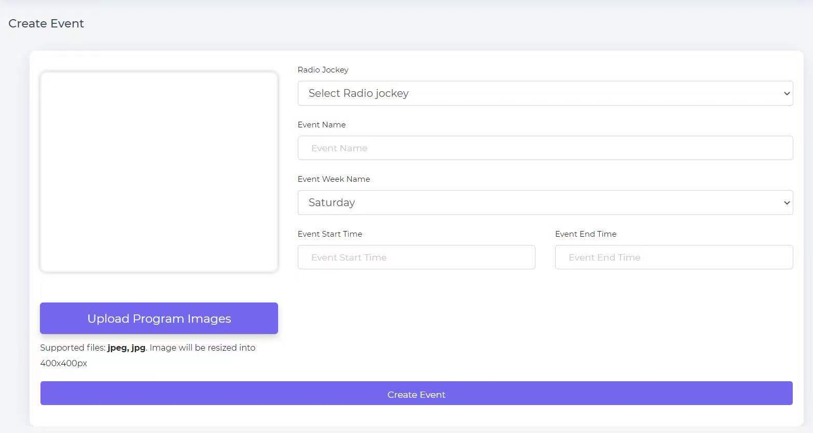 Figure 29 Create event

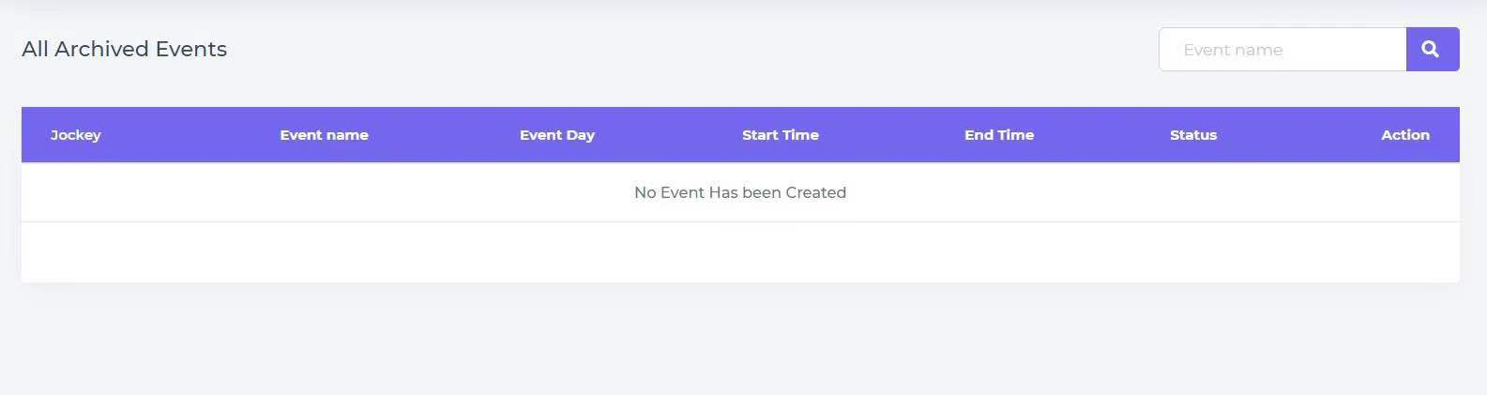 Figure 31 All archived event

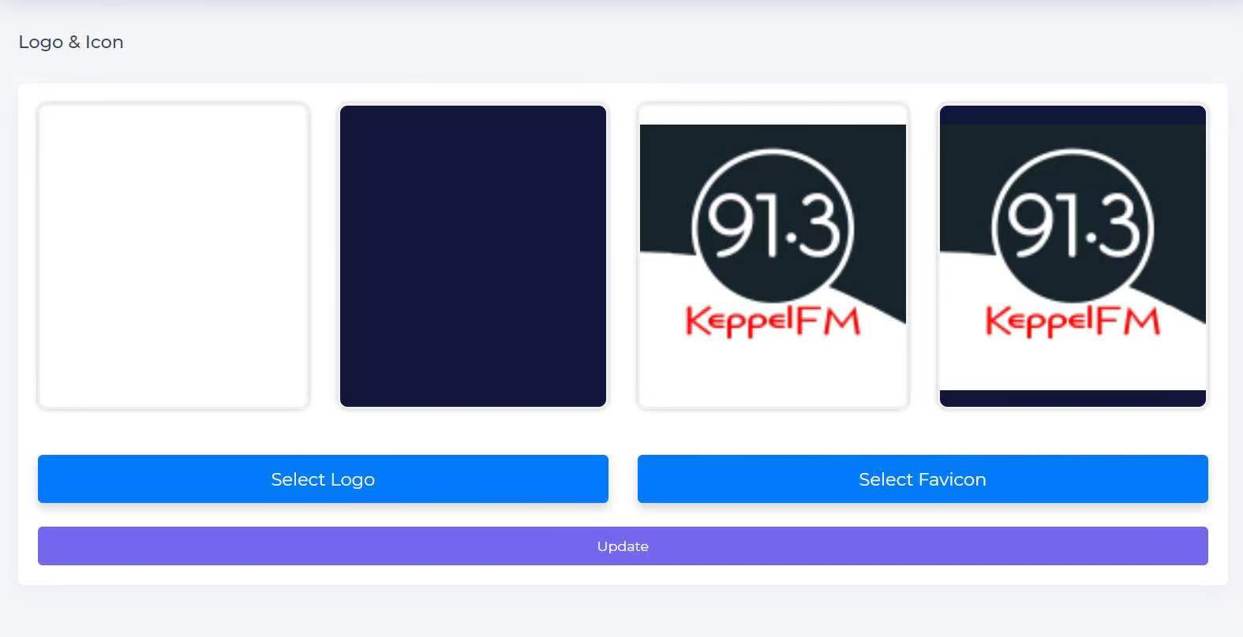 Figure 32 Logo and Icons

Reference**:**

Adam A. 2014. “Designing an MVC Model for Rapid Web Application Development”, 24th DAAAM International Symposium on Intelligent Manufacturing and Automation.